**CORRESPONDENCE**

**KUSWORO**

**International Journal of Professional Business Review**

**Author(s) :** Kusworo

**Journal Name** : International Journal of Professional Business Review

**Manuscript Title :** Government Functions Acceleration in Tourist Village Development: a Case Study of Dermaji Village

**Volume** : 8, n .3, p. 01- 18.

**Publication Year** : 2023

**DOI**  : <https://doi.org/10.26668/businessreview/2023.v8i3.1296>

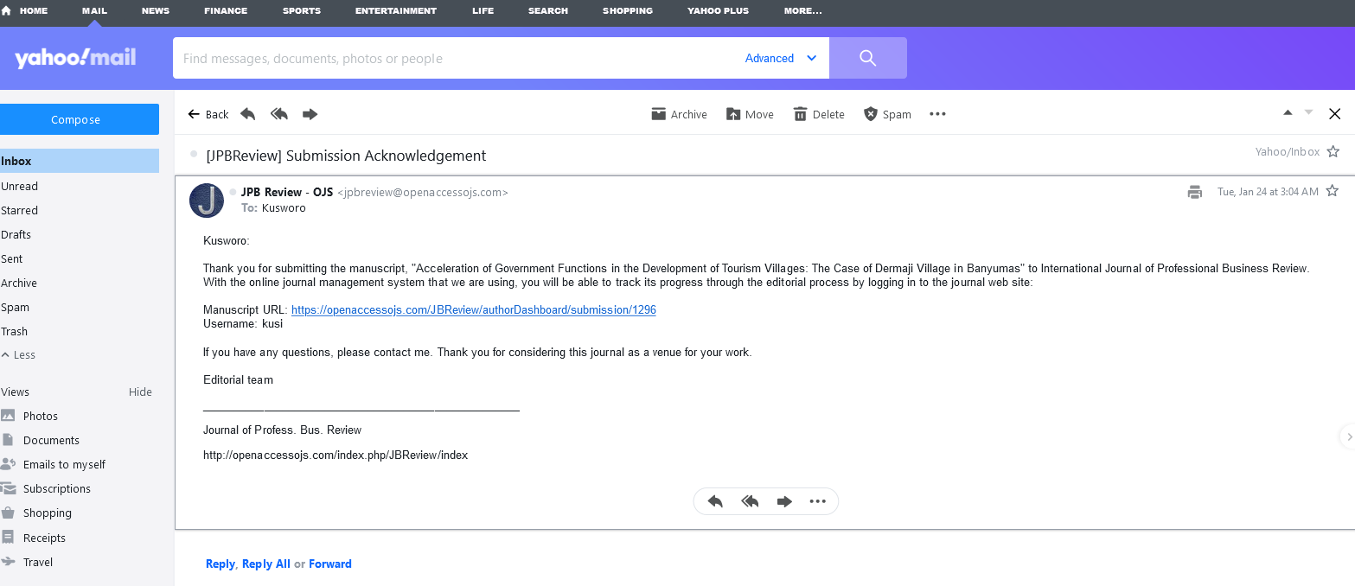

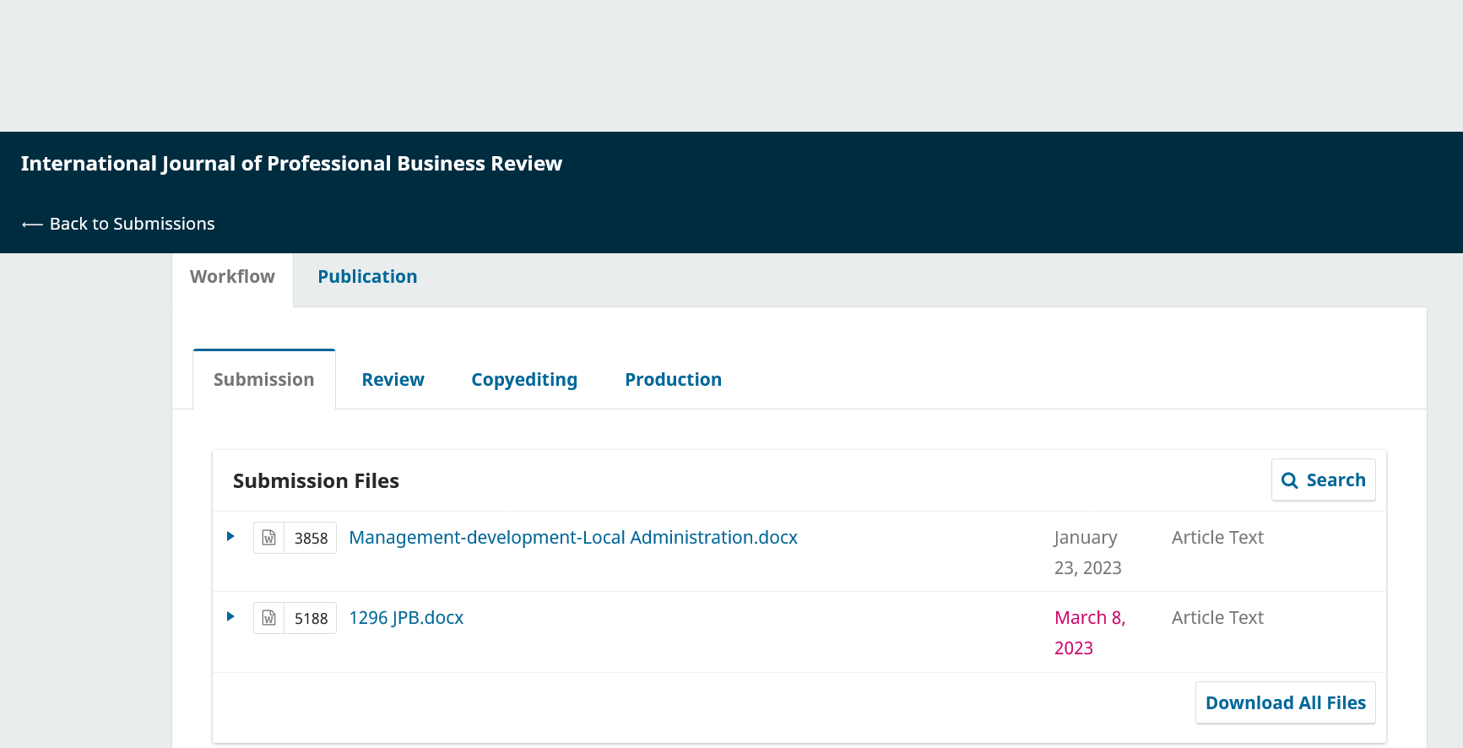

**Manuscript Submitted Before Review**

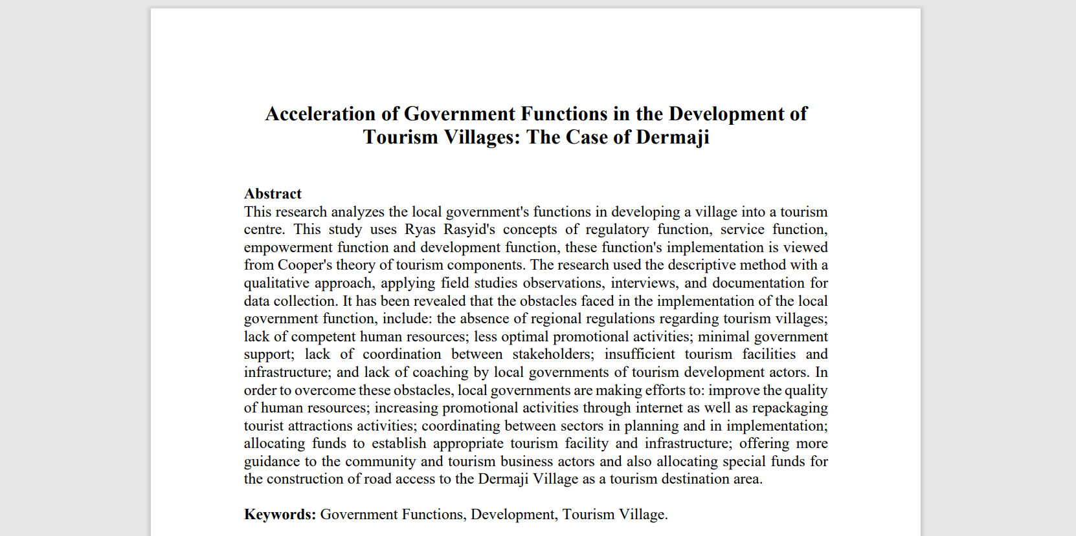

**Introductory Part of the Manuscript Submitted before Review**

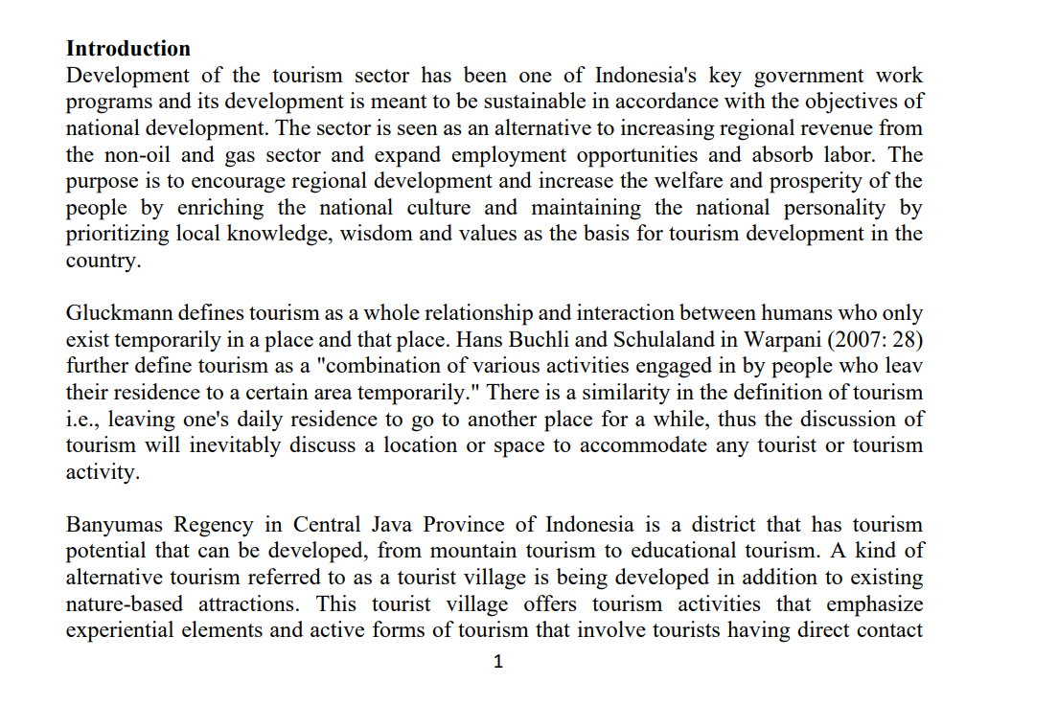

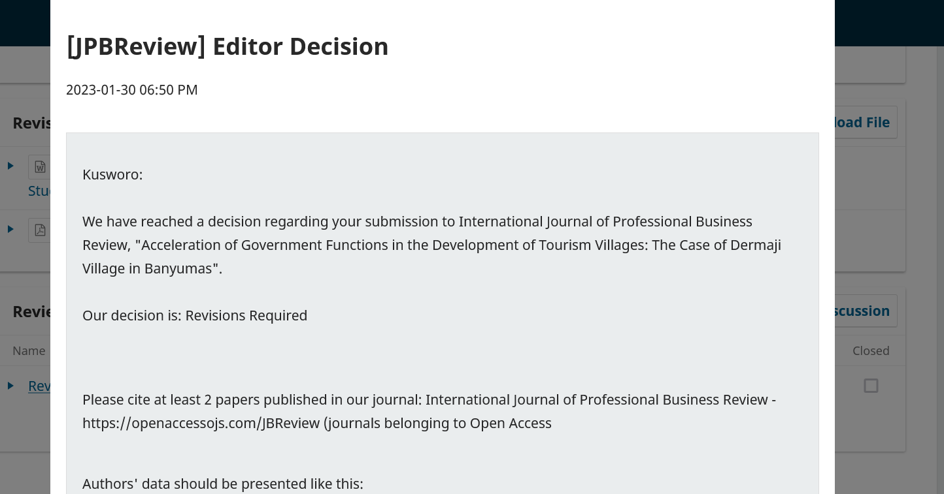

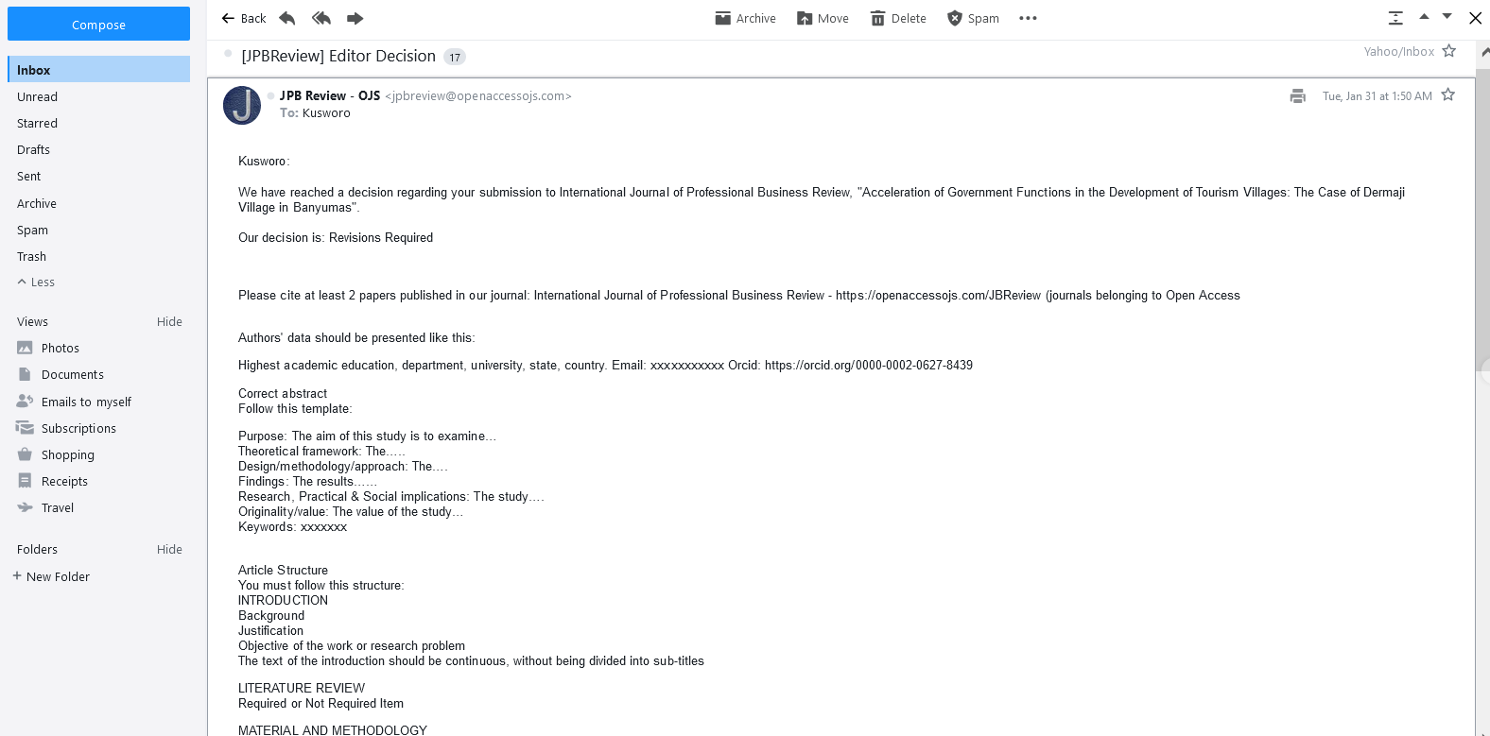

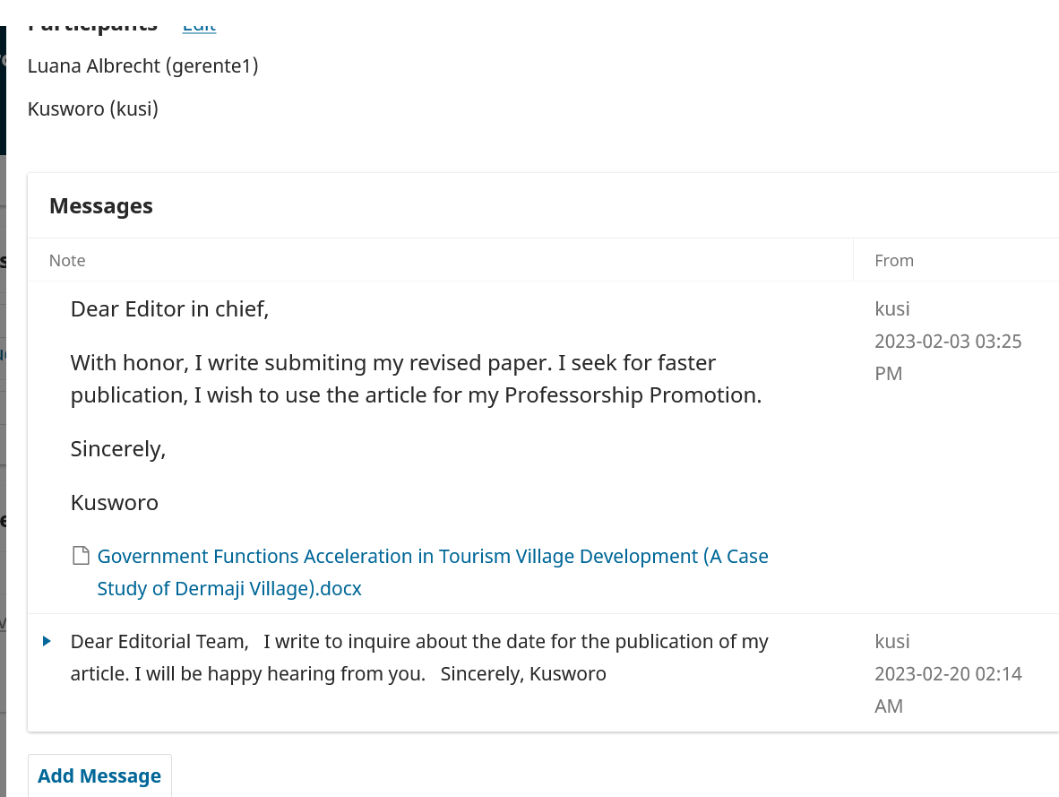

Revised Paper

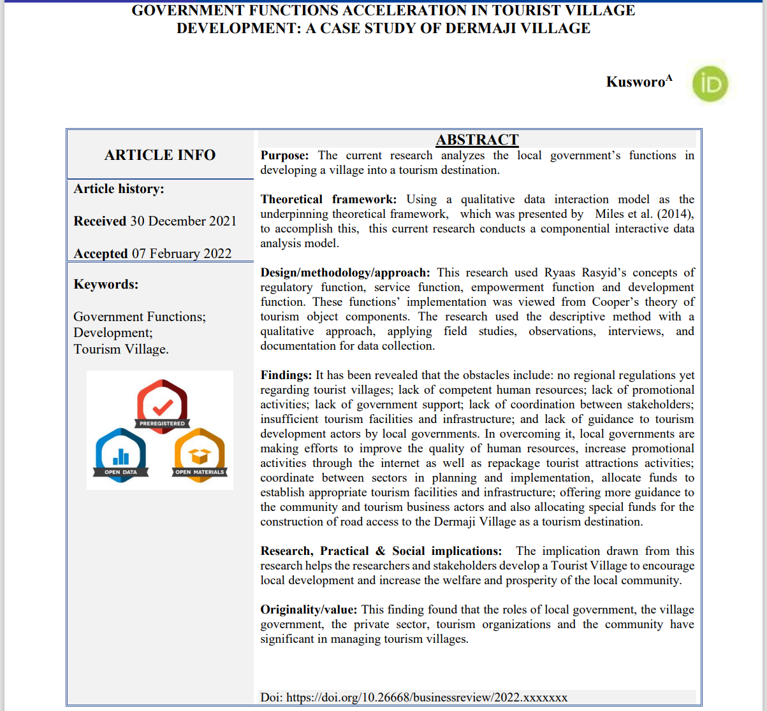

Revised Paper (Continuation)

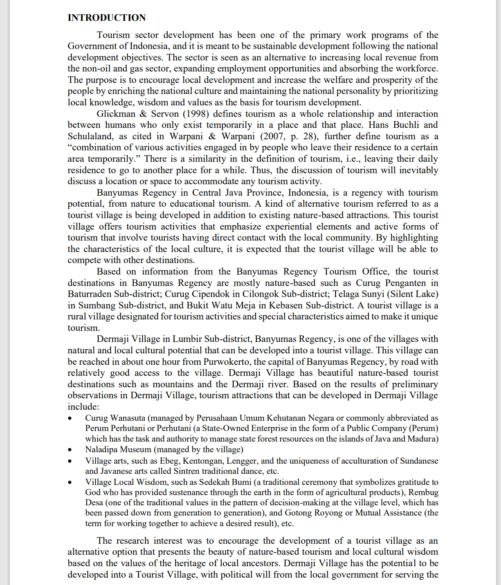

Revised Paper Parts (Continuation...)

